QiO Foresight Edge

Customer Remote Access & Edge Readiness Guide
Prerequisite guide for onsite teams
Prepared date: 29 April 2026

Contents
1. Purpose and outcome 3
2. Prepare the edge device 3
2.1 QiO-supplied edge device 3
2.2 Customer-supplied device 3
3. Connect the two networks 4
4. Confirm basic connectivity 4
5. Give QiO remote access 5
5.1 Preferred: QiO-provided DWAgent access 5
5.2 Customer-approved tools or VPN 5
6. Final readiness checklist 5
7. Appendix – DWAgent Installation Instructions 6

Purpose and outcome
This guide explains what the customer needs to prepare before QiO installs the Foresight Edge application. The aim is simple: provide the right edge device, connect it to the internet and the PLC/SCADA network, and give QiO approved remote access. QiO will complete the application, VPN, data collection, and validation work after access is available.
Success looks like this: QiO can remotely access the edge device, confirm the internet and PLC network connections, and start installation without further customer-side setup.

Prepare the edge device

QiO-supplied edge device
Instruction: Place the device near the control cabinet or network panel, connect power, connect one LAN port to the approved internet/remote-access network, and connect the second LAN port to the approved PLC/SCADA network.
- No customer software installation is normally required on a QiO-supplied device.
- Label the two cables clearly: Internet / Remote Access and PLC / SCADA.
- Keep the device powered on during the agreed access window.

Customer-supplied device
Instruction: Provide a PC, industrial PC, or server-class workstation that customer IT can support and patch. Windows is preferred when that is the fastest customer-supported route; Linux can be used as well if agreed with customer IT.
- Preferred memory: 16 GB RAM. Lower RAM may be acceptable by agreement for small pilots.
- Preferred storage: 200 GB available disk. Increase this if longer local data storage is required.
- Network: two LAN ports or two separate network adapters are required.
- Access: a temporary local administrator route, service account, or supervised installation window is required.
Why this matters: Two separate network connections let QiO read PLC/SCADA data while keeping the internet/remote-access path separate from the control network. Local storage is used for buffering data if cloud back-up is not opted.

Connect the two networks
Instruction: Use one connection for internet/remote access and one connection for PLC/SCADA access. Do not bridge, share, or route traffic between these two networks.
- Connect LAN 1 to the approved internet or remote-access network.
- Connect LAN 2 to the approved PLC, SCADA, OPC, or industrial-control network.
- Confirm LAN 1 has a valid IP address for the internet/remote-access network.
- Confirm LAN 2 has a valid IP address on the same network as the PLC/OPC endpoint that QiO will read.
- Confirm customer IT/OT has not enabled routing, bridging, or internet sharing between LAN 1 and LAN 2.
Why this matters: QiO needs remote access to the edge device and read access to the PLC/SCADA data source. The edge device should not act as a route between the internet and the control network.

Confirm basic connectivity
Instruction: Run these checks before the QiO installation session or have the customer IT/OT contact ready to run them with QiO during the session.
- Internet side: confirm the device can open the approved remote-access tool or customer VPN route.
- PLC side: confirm the device can reach the approved PLC, SCADA, OPC, or gateway IP address from the PLC network adapter.
- IP check: record the IP address of each adapter and which network each adapter is connected to.
- Security check: confirm the firewall allows the agreed remote-access method and any customer-approved cloud/VPN destinations.
Good outcome: the internet connection works, the PLC/SCADA connection reaches the approved endpoint, and QiO can verify that the two network paths remain separate.

Give QiO remote access

Preferred: QiO-provided DWAgent access
Instruction: QiO will provide a DWAgent installation script or installer and an installation code. Run it on the edge device during the agreed setup window. When prompted, use the installation code provided by QiO.
- Download or copy the QiO-provided DWAgent installer or script onto the edge device:
- For windows: https://www.dwservice.net/download/dwagent_x86.exe
- For other OS devices: https://www.dwservice.net/en/download.html
- Run the installer or script using the customer-approved administrator process. Please refer to the appendix for step by step instructions on DWAgent installtions.
- Enter the QiO-provided installation code when prompted.
- Tell QiO when the agent is installed and the device is online.
Why this matters: This gives QiO a controlled remote session so QiO can install the VPN, configure the application, validate the PLC/SCADA connection, and troubleshoot without requiring a separate onsite approval route.

Customer-approved tools or VPN
Instruction: If customer IT prefers another approved method, QiO can support it. Examples include customer VPN, jump host, Remote Desktop through an approved gateway, TeamViewer, AnyDesk, UltraViewer, NoMachine, RustDesk, or a similar customer-approved remote-support tool.
Send QiO the following information through the customer-approved secure channel:
- Remote method name, device name, site name, and agreed access window with timezone.
- Session link, connection ID, VPN/jump-host details, or other connection reference.
- Temporary password, one-time code, or MFA approval contact, if required by customer policy.
- Name, phone number, and email of the customer IT/OT contact who can approve access or assist during installation.

Final readiness checklist
- Edge device is powered on and located near the required network connections.
- Internet/remote-access LAN and PLC/SCADA LAN are connected to the correct ports and clearly labelled.
- Both adapters have valid IP addresses for their respective networks.
- The PLC, SCADA, OPC, or gateway endpoint is reachable from the PLC-side adapter.
- Remote access is installed, enabled, and shared with QiO for the agreed window.
- A customer IT/OT contact is available for firewall, VPN, MFA, or PLC network questions.
Once these items are complete, QiO can remote in and complete the Foresight Edge application installation and validation.

Appendix – DWAgent Installation Instructions
- Download the Agent installer for your device from our download page (https://www.dwservice.net/download.html).
- After downloading the file, open it to start the installation process.
- A wizard will be launched to guide you through the installation.
  - From the options, select Install.
  - Click on the Next button.
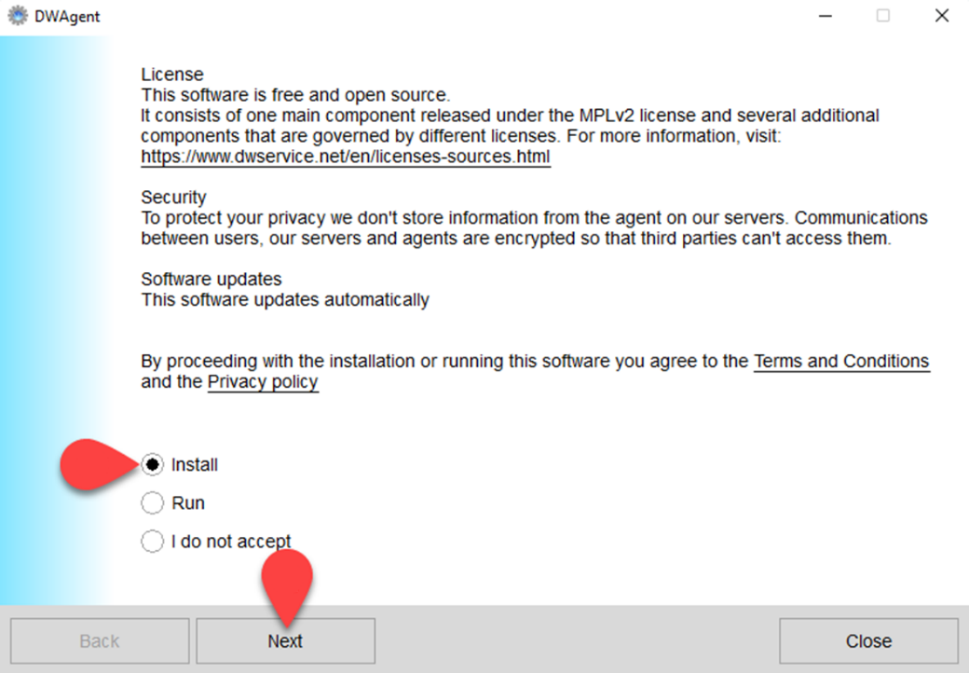
- Here you can see the location where the Agent will be installed. This is the default path.
  - If you want to install the Agent somewhere else, you can change the path here.
  - Click on the Next button.
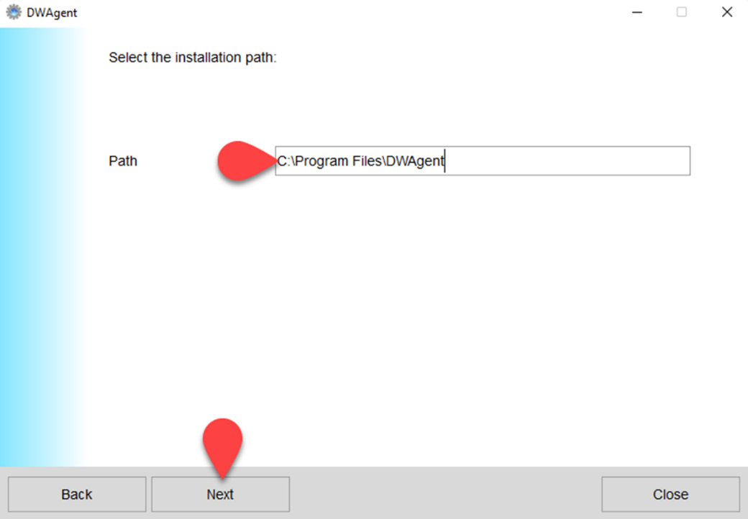
- The next page of the wizard is displayed:
  - Select Yes to confirm that the specified installation path is correct.
  - Click on the Next button.
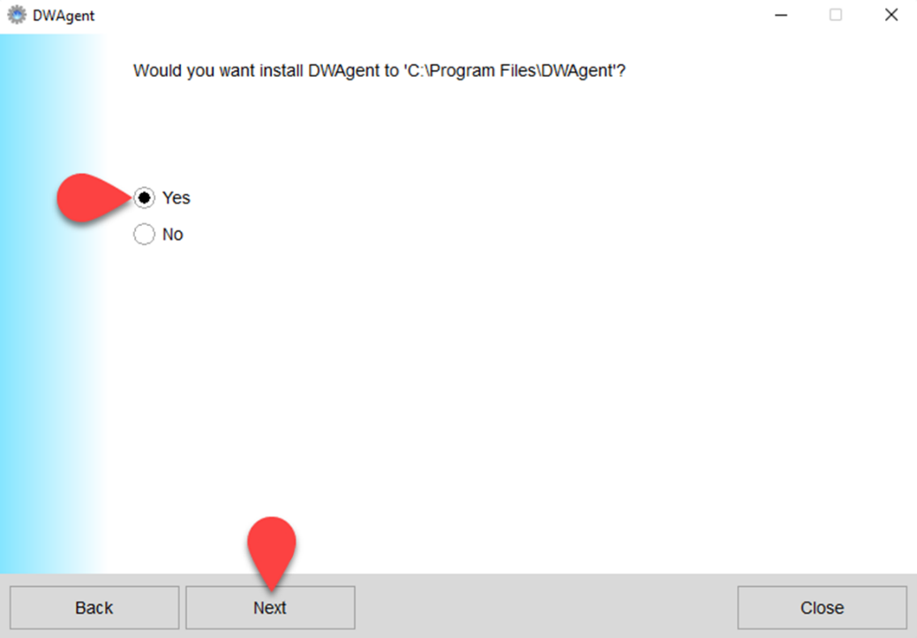
- The next page of the wizard is displayed:
  - From the two installation modes, select the ‘Enter the installation code‘ option.
  - Click on the Next button.
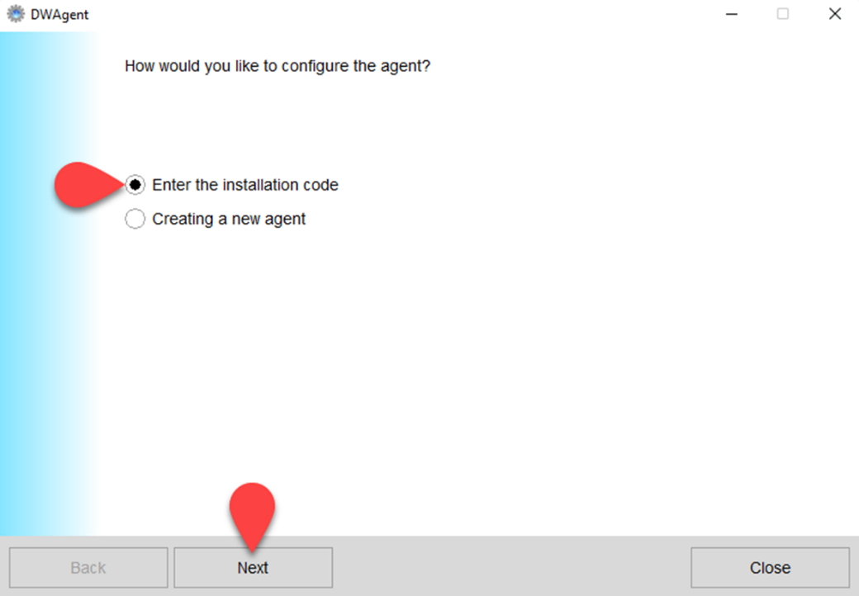

- The next page of the wizard is displayed:
  - In this field, enter your Installation code. This is the 9 digit code that the QiO generated for this particular installation.
  - Click on the Next button.
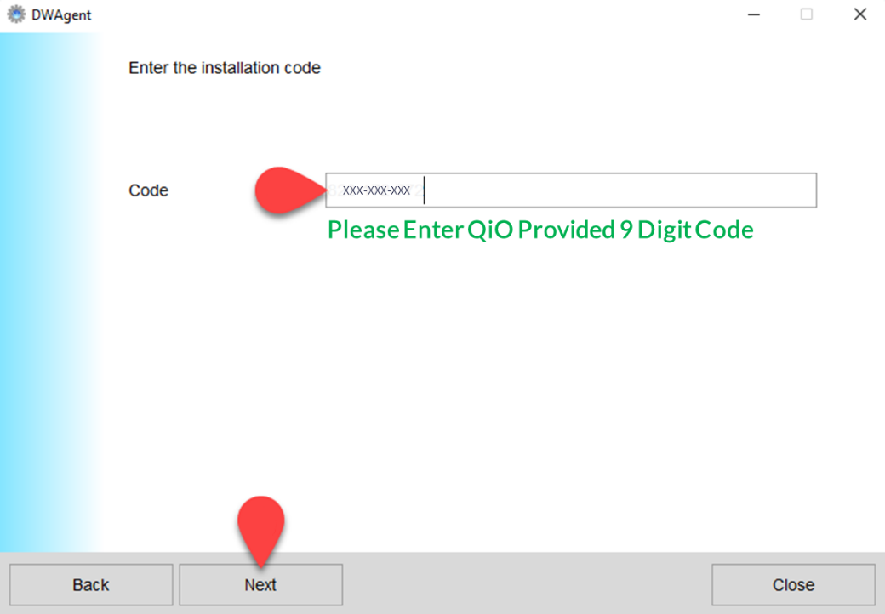
- After installation, the Monitor icon appears in the taskbar.
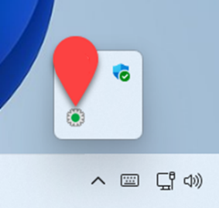
- Click on the Monitor icon to show the DWAgent – Monitor window.
